**Tema Poster 1 :**

**Legacy terbesar selama menjabat sebagai KPS S1 Sistem Informasi UNAIR (Sept 2017 s.d. Des 2019)**

Jawaban :

* Semangat untuk membawa mahasiswa dan dosen Program Studi S1 Sistem Informasi dalam *academic excellent*, *research excellent*, dan *community service excellent* yang lebih terkemuka secara nasional maupun internasional.
* Collaboration with abroad company and universities:

1. Osaka University, Japan, Institute for Scientific and Industrial Research (2015 - now)
2. Marimo Global Technology Co., Ltd., Tokyo, Japan (2019 - now)
3. Asia University, Taiwan, Department of Photonics and Communication Engineering (2018 – now)
4. National Taiwan University of Science and Technology, Taiwan, College of Electrical Engineering and Computer Science (2018 - now)
5. National Cheng Kung University, Taiwan, Department of Industrial and Information Management (2019 - now)
6. Universiti Teknologi MARA (branch Perlis), Malaysia, Faculty of Computer and Mathematical Sciences (2018 - now)
7. Universiti Teknologi MARA (branch Shah Alam), Malaysia, Faculty of Computer and Mathematical Sciences (2019 - now)
8. Universiti Kebangsaan Malaysia (2019 - now)
9. Management and Science University, Malaysia, Faculty of Information Sciences & Engineering, Department of Information Sciences & Computing (2019 - now)
10. Singapore Management University, Singapore, Department of Information Systems (2019 - now)
11. National University of Singapore (2019 - now)

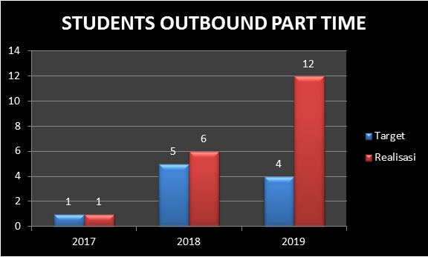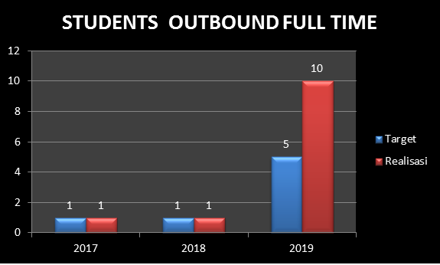

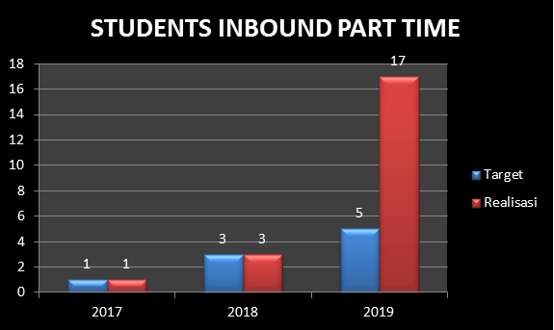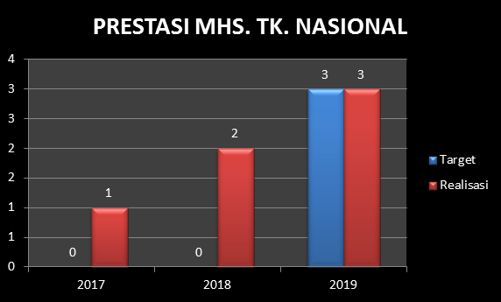

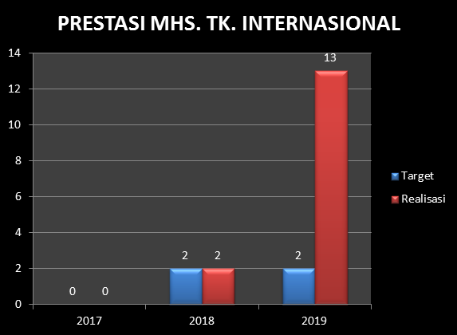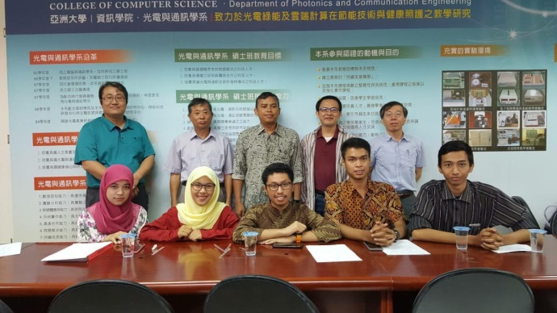

**Collaboration with Asia University, Taiwan**

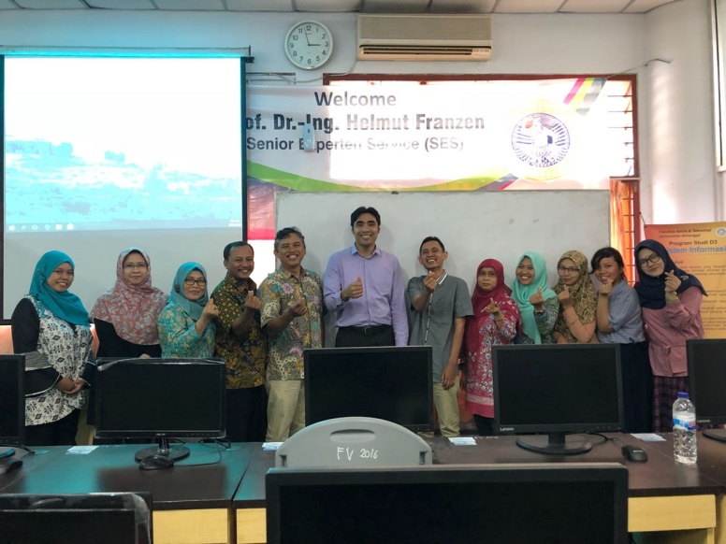

**Collaboration with UiTM Perlis, Malaysia**

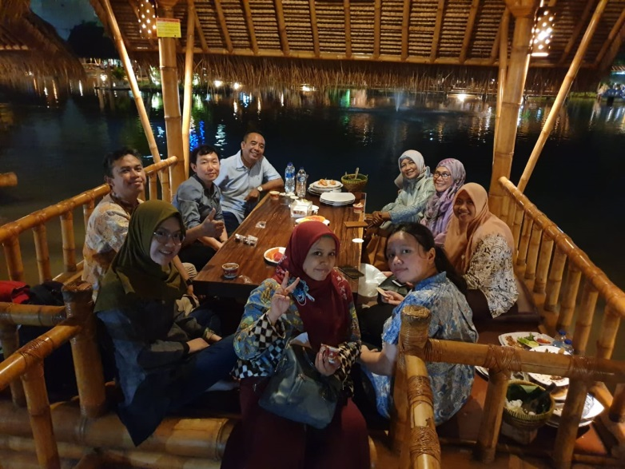

**Collaboration with SMU, Singapore**

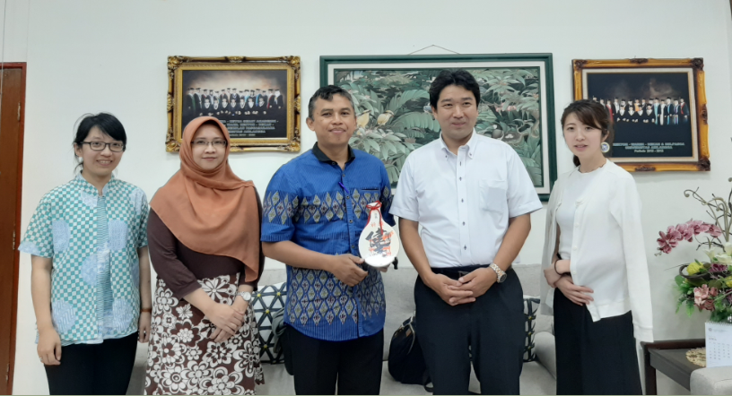

Collaboration with Marimo Global Technology Co., Ltd., Japan., Ltd., Tokyo, Japan

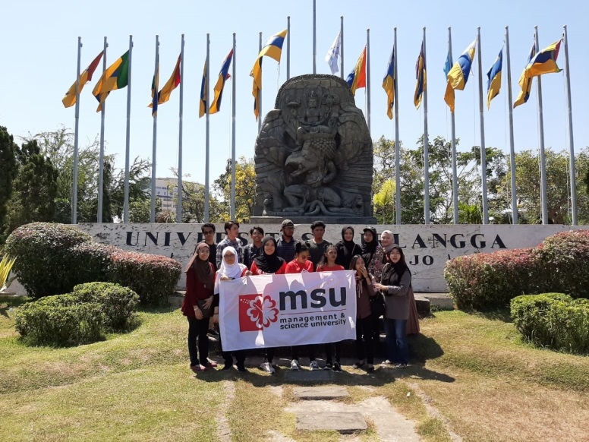

Collaboration with MSU., Malaysia., Ltd., Tokyo, Japan

**Tema Poster 2 :**

**Peningkatan “nilai jual” lulusan Program Studi S1 Sistem Informasi UNAIR**

* Magang bersertifikasi di lembaga/industri/industri multinasional/pemerintah selama satu semester (enam bulan) yang setara dengan 12 s.d. 18 sks (mata kuliah pilihan).
  + Magang di lembaga/industri/pemerintah yang sudah terlaksana (pakai logo) : Bank Indonesia, Bank Muamalat, PT Telkom, PDAM, PJB, PT Pelindo III, PTPN X, DSI UNAIR, Asia University (peneliti), Apple Academy, kerjasama dengan MSU Malaysia (on progress), Instansi pemerintah, Startup-startup.
* Menciptakan startup baru (Logo alumni : riliv, jejakku -> upward project, olympiade.id)
* Memberikan kesempatan mahasiswa untuk mendapatkan pengalaman internasional. (tambahin gambar)

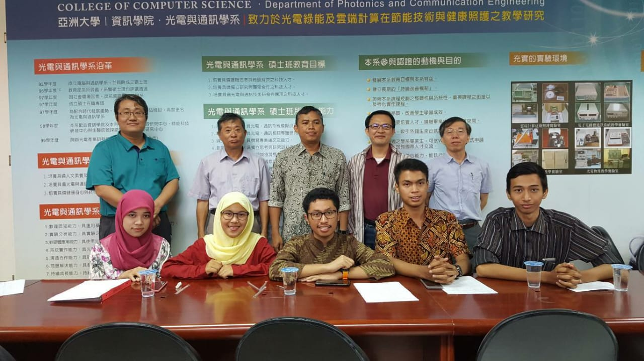

**Student Outbound to Asia University, Taiwan 2018**

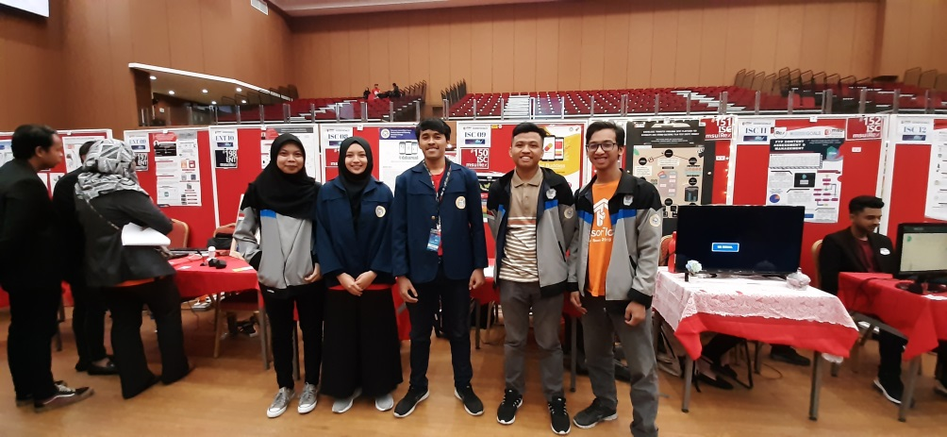

**International Competition to MSU iREX Malaysia 2019**

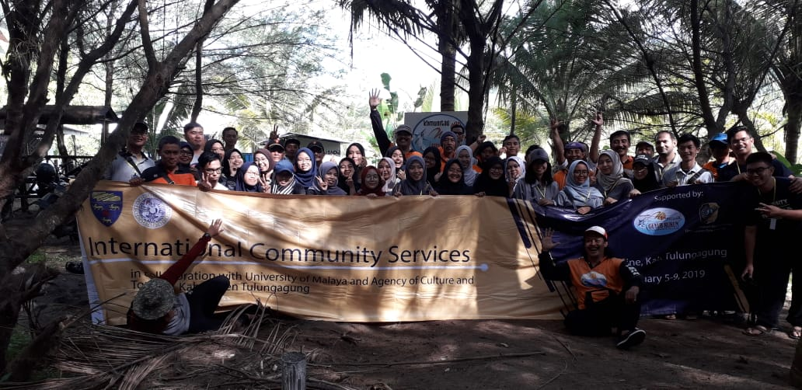

**International Community Services at Sine Beach 2019**

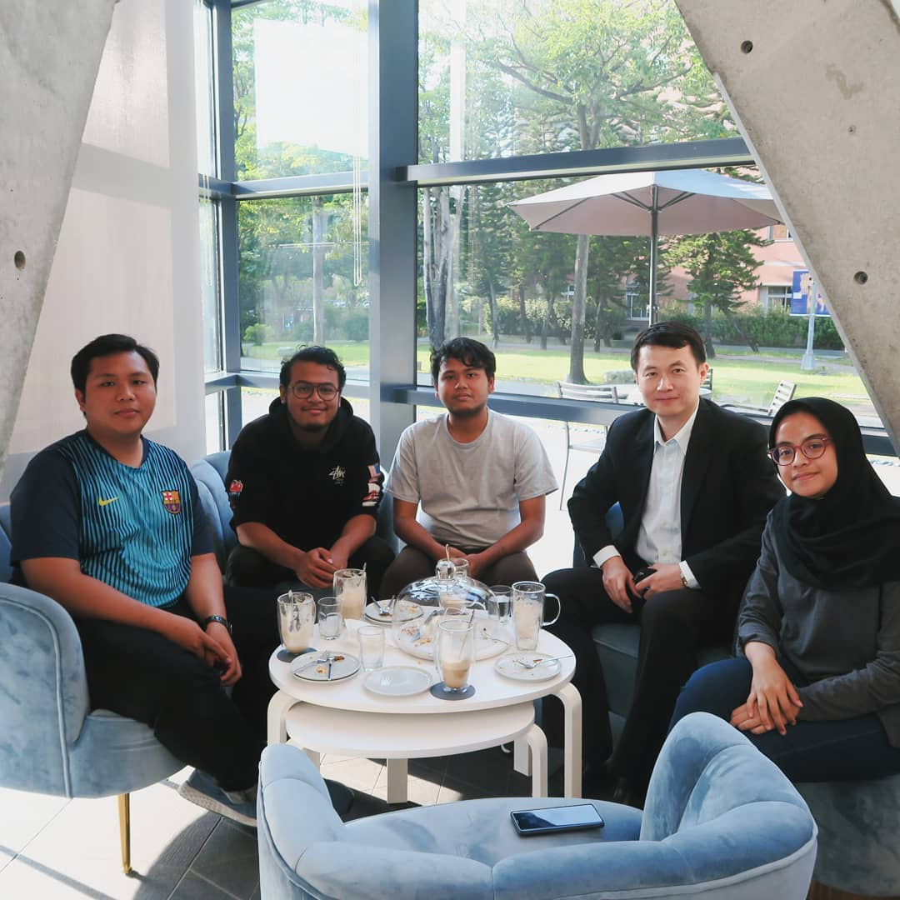

**Internship student at Asia University Taiwan (2019-2020)**